Art Technical Specification

Revision History
Issue | Date | Person | Comments
0.1 | Mar 11, 2002 | James Ceraldi | Draft outline
0.2 | April 11, 2002 | Cary Brisebois | Added data
1.0 | April 12, 2002 | Cary Brisebois | Reviewed by team and released
1.1 | April 17, 2002 | Darryl Long | Added NIS spec

1. Simpsons II Art Technical Specification 3
1.1 Intro 3
1.2 Content Categories 3
1.2.1 Vehicles 4
1.2.2 Characters 7
1.2.3 World Geometry 11
1.2.4 Props (Moveable and Static) 15
1.2.5 Collision volumes 16
1.2.6 HUD and FE art 16
1.2.7 Particles 17
1.2.8 NISes 18
1.2.9 FMVs 18
1.3 Performance Issues 19
1.3.1 Tri-Stripping 20
1.3.2 Indexed Primitives 21
1.3.3 Triangle counts in Maya versus in-game 22
1.3.4 Alpha issues 22
1.3.5 Draw distance 23
1.3.6 Texture issues such as 128x128 max size 23
1.3.7 Shaders (Materials) 26
1.3.8 Primgroups—one of the most important but overlooked areas from SRR. 27
1.3.9 Skeletons 27
1.3.10 Lights 33
1.3.11 Lighting Restrictions 35

Simpsons II Art Technical Specification

Intro
The purpose of the art technical specification is to set general guidelines and limits for the content in the game as well as detail specific issues for each target platform as related to content. This document is meant to be short and direct so that the main risk areas are focused on and known to all. It will be updated and expanded throughout the project. Although for the entire team, the art tech spec is most useful for the artists creating the art. This document is only the first step in a process that will not only improve workflow efficiency and content quality but will also reduce risk and improve in-game performance. A separate memory map document is used to specify total memory allocations and limits. Also supporting this art spec document will be a content database that verifies that each type of content complies with the specs outlined in this document. Below is the flow of how we will tackle more efficient content construction and error detection:
Art Tech Spec->Creation of Content->Rules in Exporter->Verification in Database->Rules in Pipeline
Both the art tech spec and the memory budget will help ensure that we can fit the game into memory on the various platforms. The memory budget will give exact numbers available for the content areas and will help the artists by providing limits and give direction to the designers for how much content they have to work with for each mission. The memory budget will be enforced through the content database that will give an approximate memory count for each level as it is constructed. As well, the game will verify the exact numbers at load time to ensure that every category complies with the budget.
Art Tech Spec->Memory Budget->Feedback from Database->Checks at Load in Game
The art tech spec is divided into two parts:
- Content categories--discussion of areas of art to create construction specs and guidelines
- Performance issues--discussion of the major terms with regards to rendering such as tri-stripping and how it affects rendering. We will discuss these topics in a presentation.

Content Categories
There are several main categories of the game content that need specifications to ensure that the data can be used in the game. There are many issues that need to be outlined for each category but the main concerns are those that affect frame rate (performance) and memory usage. The main areas of game art are as follows:
- Vehicles
- Characters
- World geometry
- Props
- Collision volumes
- HUD and FE art
- Particles
- NISes
- FMVs

Vehicles
There are three types of vehicles planned for the game:
- Driveable
- Chase
- Traffic
The issues that need to be resolved are as follows:
- Meshes—the number of meshes, primgroups, and poly counts. Primgroups are hard to control as they are determined by the topology of the mesh and the mechanisms for processing them. It is not known which method we will use for damage states: multiple-meshes or vertex offsets.
  - Drivable: 1500 triangles for vertex offset damage states, 2300 for multiple-mesh damage states
  - Chase
    - AI Boss-type: 1500 triangles for vertex offset damage states, 2300 for multiple-mesh damage states
    - Generic: Between 700 – 1000 triangles for vertex damage states, 1000 – 1500 triangles for multiple mesh states.
  - Traffic: 300 triangles
- Mesh naming conventions
  - TBD: Greg
  - Wheels 0 – 3: w0, w1, w2 , w3 (See screen-shot below)
- Shaders—nightime versus daytime
  - Not an issue. The cars will only have one set of shaders regardless of what time of day they are used.
- Textures
  - Drivable: 3.75 128x128x8bit textures; 4 levels mip map (5 on Xbox)
  - Chase
    - AI Boss-type: 3.75 128x128x8bit textures; 4 levels mip map (5 on Xbox)
    - Generic-type
  - Traffic: 1 128x128x8bit texture; 4 levels mip map (5 on Xbox)
- Lighting
  - All cars are lit dynamically by the light in the level. No special exports for different time of day.
- Shadows—the methods are different for PS2, Xbox, and GC
  - Drivable: Using similar technique as SRR there is a single shadow volume for each car, does not reflect animations or damage states. Recommend: look at adding volumes for animated parts of the car for the XBOX.
  - Chase: Same as Drivable
  - Traffic: Same as Chase only these use simpler volumes.
- Locators
  - Seat positions for driver, and passengers
  - Locations of the door handle for opening door animations
- Animations--swinging doors, flapping hoods, animating antennas.
  - These are driven by physics: Greg
- Toon lines
  - Each mesh in the vehicle’s composite drawable will need a simplified toon mesh. This way, animations on the car will have their toon-line animate with them. If we use vertex-offset animations for damage states, the same animation must be applied to the toon-line mesh.
- Damage states
  - TBD. There are two possible methods:
    - Vertex Offset Animations:
+ Artist preference
+ Adds extra damage states as the vertices are animated linearly
+ Lower poly count
- Forces the meshes that are animated to be skins (could be very slow)
- Simpler hierarchy
    - Multiple meshes for each damage state.
+ Higher poly count
+ Buffered prims (faster)
- More complicated hierarchy
- Discrete damage states
- Vehicle skeleton and joint naming conventions
  - The current requirements are as in the following example.
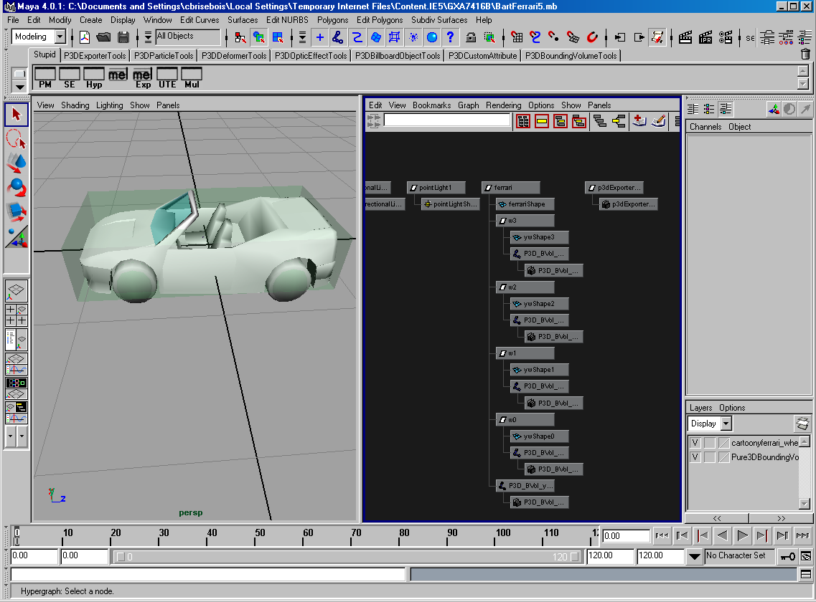
Example Maya Hierarchy for Cars
  - There will need to be some additions to the hierarchy of the car to add such things as character placement and door handles. Also, this hierarchy does not support multiple damage-state meshes or animated pieces (hood, doors).

Characters
There are three types of character models in the game:
- Walkable models
- Driver models (Recommend: use the walkable model as the driver too)
- Pedestrian models
The issues that need to be resolved are as follows:
- Poly counts
  - Walkable 1700, 600, 200 triangles (high, medium, low)
  - Pedestrian 600
- LOD levels
  - 3 High, med, low, no sprite
- Skeleton--number of bones/joints
  - Walkable: 46 joints (This is the Radical generic skeleton. We are experimenting with a skeleton that has 28 bones instead)
  - Pedestrian and other less-important characters: suggest < 30 joints
- Bone weighting
  - The more weights the more computation. Only the high LOD characters should be fully weighted. (We are experimenting with non skinned or half-skinned characters to save on streamed primitive overhead when rendering.)
- Texturing
  - Recommend: Only two texture maps per character max.
  - Player character: 10K DXTN or 90K (PS2)
  - Pedestrian or lesser-characters: 10K DXTN or 90K (PS2)
- Locators
  - Position for where character hands touch other objects (door handles, switches)
- Animations
  - All Characters
    - Idle
    - Blinking
    - Mouth Flapping
  - Walkable
    - Walk
    - Run
    - Turn
    - Lean
    - Slow and turn 180
    - Bump into wall
    - Bump into person
    - Knocked down by vehicle
    - Get up
    - Falling
    - Flail
    - Activate switch
      - Child
      - Adult
  - Driver
    - Turn to look backwards
    - Turn Left
    - Turn right
    - Decelerate
    - Accelerate
    - Wave
    - Wave Goodbye
    - Idle
    - Bounce
    - Sway
    - Crash
  - Passenger (These are for three body types: child, old normal)
    - Point left
    - Point right
    - Point ahead
    - Look back
    - Look left
    - Look right
    - Get in car
    - Get out of car
    - Bounce
    - Sway
    - Idle
    - Cheer
    - Crash
    - Catapult out of car
  - Pedestrians
    - Walk
    - Run
    - Turn
    - Lean
    - Slow and turn 180
    - Bump into wall
    - Bump into person
    - Knocked down by vehicle
    - Get up
    - Falling
    - Flail
    - Reaction to being bumped into
    - Cower from vehicle
    - Dodge
    - Near miss (angry)
    - Dodge (flatten against wall)
- Naming conventions
  - Each animation needs a unique descriptive name.
  - Other restrictions TBD by TBJ
- Drop shadow
  - Simplified geometry or blob-sprite? It is recommended that we start with blob-sprites for pedestrians. During conversations and NIS we could do geometry for shadows.
- Facial animation and joints
  - Facial animation is driven by a jaw-bone joint for all skeletons.
- Lighting
  - Dynamically lit using level’s light source.

World Geometry
The static geometry that makes up the game include:
- Terrain
  - Drawable geometry and simplified intersection mesh.
  - Driveable terrain (track) and non-driveable terrain
- Buildings
  - Generic apartments, houses, commercial, and industrial structures.
- Landmarks
  - Characters’ home
  - Special buildings (town hall, school)
- Building facades
  - Generic buildings that can not be driven around.
The issues that need to be resolved are as follows:
- Poly counts
  - Static geometry max. triangle count: TBD needs more testing.
  - Recommend: we schedule some time for implementing simple dynamic loading.
- Mesh naming conventions
  - Each mesh should be named differently than the default Maya naming. This will be tested by the art database.
- Shadow maps
  - TBD Darryl / Devin
- Textures: The totals refer to the number of 128x128 texture maps. The total memory size of static textures allowed is 5 Megabytes per level. The following chart shows one level with one subzone, more realistic numbers would multiply the number of zones and subzones by 4. Max texture size for static geometry 4 Megabytes.
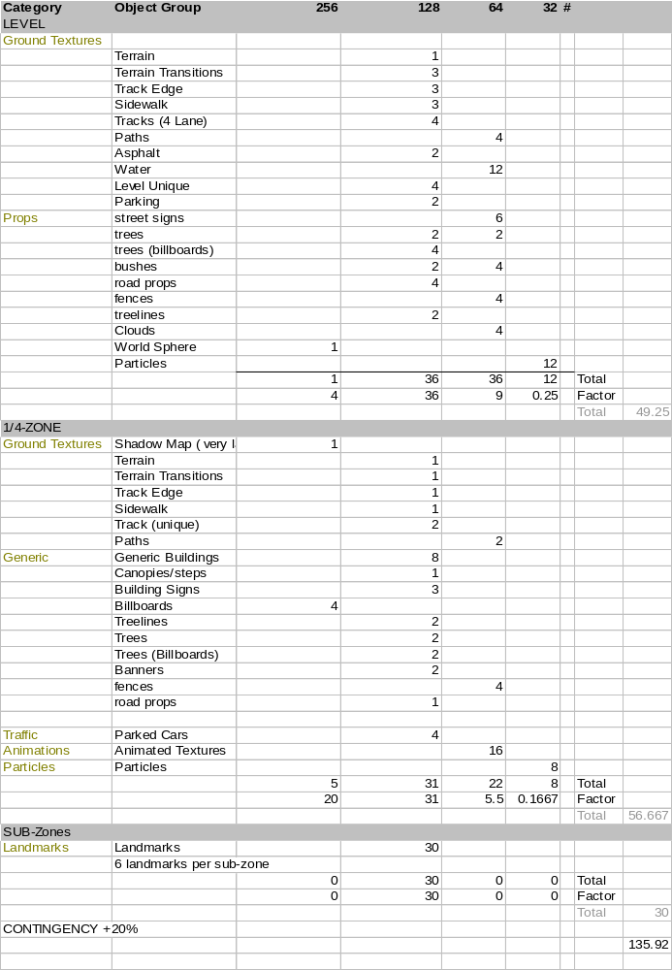
- Lighting
  - Prelit with new prelighting tool. Additional shadow map applied. (See above)
- Shaders
  - TBD: Devin / Darryl
- Toonlines
  - No toon lines on static geometry
- Animated physics objects
  - See Greg’s physics demo.
  - Two categories of animated physics objects
    - Looping: Always animating in the world
    - Triggered: Animation controlled by switch in the world
These objects have infinite mass and will not be dislodged from their animation. They do, however, collide with the player objects and other world physics objects.
- Texture animation
  - Texture animations are fine. They must be built at the origin.
- Mesh animation
  - Must be built at the origin to prevent floating-point errors.
- World sphere and horizon
  - Single layer is preferred. Multiple layers need further investigation.
  - 1 128x128x8bit map
- Construction issues such as inter-zone connection length and node length
  - TBD: We need to lock down the speed of the car and calculate the amount of time needed to dump and load sub-zone data.
  - This is a risky area that will affect the decision on what to dynamically load.

Props (Moveable and Static)
In SRR, most of the props were moveable but they were treated all the same. Instead of having animations, we used physics for everything including breaking glass. This reduced our game performance and did not look very good either. For Simpsons II, there will be the concept of a breakable which will be hit, animate with a particle effect and disappear. Moveables may have particle effects as well but they will use the physics system when hit. The objects in the game which are props include:
- Breakable objects (Glass, trees etc.)
- Moveable objects (Rocks, mail boxes etc.)
- Statics (Telephone poles etc.)
The issues that need to be resolved are as follows:
- Categories of objects
- Poly counts
  - Max triangle counts for prop objects (per level): TBD needs more testing.
- Textures
  - Max texture size for prop geometry 2 Megabytes.
- Mesh naming conventions
  - All meshes shall not use the default Maya naming system
- Shaders
  - TBD: Devin
- LOD
  - Recommend: 2 levels of LOD. Low LOD as a sprite is a good idea.
- Particle effects
  - Not actually tied to the prop, but defined through a script that recognizes which prop is collided with.
- Animations
  - TBD: we may not support animating objects that respond to collision. This is TBD Greg.

Collision volumes
Collision volumes are the representation of geometry in the physics system’s point of view. Each collision volume bounds some geometry and is representative of its shape. There are three types of collision volumes:
- Static (buildings)
- Dynamic (chairs, debris)
- Animated (bridges, ferries)
The issues that need to be solved are as follows:
- Naming conventions
  - TBD: It is likely that Simpsons 2 will not require as strict a naming convention as SRR, however, each collision volume will need a specific and unique name that is not the Maya default.
- Collision volume hierarchies (articulated)
  - The physics collision system supports articulated (hierarchical) collision volumes. This allows the collision system a much faster way of rejecting collision pairs.
- Effects of animated physics volumes on player objects
  - TBD: Greg. Currently, all animating physics objects are of infinite mass, so when a collision occurs, the animating object moves the player object.
- Density of collision volumes in any given region of space
  - Maximum 20 of both static and dynamic physics collision volumes per 50M Radius. This will be tested in the pipeline. Essentially, each physics volume should only have another 19 of the same type near it within 50M.

HUD and FE art
HUD and Front End (FE) art are primarily textures. There are two types of HUD or FE art:
- Static texture
- Animated texture
The issues with HUD and FE art are:
- Texture size
  - HUD: 3 128x128x8bit maps
  - FE: TBD
- Texture bit-depth
  - HUD: 8bit per pixel
  - FE: TBD (This is not a major issue)
- Localization of words embedded in textures
  - Recommend: NO localized text in textures. All localizable text shall be in a text file.
- Texture naming conventions
  - As with all art, each texture that is unique should have a unique name. Textures that are the same should share a name.
- Scrooby parsing
  - This is an issue if we use the XML text parsing. Late in SRR we were able to use P3D chunks to parse the scrooby data, we should do likewise with Simpsons 2.

Particles
Issues with particles:
- Max particle limits
  - Max 100 particles of any kind at any time. How this translates into data for the artists? Hard rule: Use as few particles as possible, use larger ones to simulate more at a time. No particle system should be producing more than the max at any given time. There is also an upper limit to the total number of particles from all running particle systems, but that is TBD.
- Naming conventions
  - No strict naming conventions yet. For SRR each particle system was named the same as the sound effect associated. This will likely be true for Simpsons 2, however, this is TBD.
- Textures
  - Max texture size per particle system: 1 32x32x4bit map with alpha.

NISes
Issues with NISes:
- Character LOD poly counts
  - We are using the same characters and props for the NISs as in the main game. These will be the high LOD versions. No new art is required.
- Naming conventions
  - As with all Maya objects, do not use the default naming system.
  - The Camera must be named “Camera”
  - The SceneGraph must be named “Scene”
  - The MasterController must be named “MasterController”
- Animation sequencing and synchronization with sounds
  - TBD
- Textures
  - All major objects shall be the same as used in-game. See texture requirements for those components in their sections.
- Particles
  - Same rules for particles apply here as they do the main game. See above.
- Lighting
  - Prelight as much as possible, dynamicly light as little as possible.
- Toonlines
  - Since there will be no toon lines on characters or world objects other than the car, it is recommended that there be no toonlines on NIS elements either.

FMVs
FMV issues:
- Resolution
  - PS2
    - 640x448 NTSC
    - 640x512 PAL
  - XBOX
    - 640x480 PAL/NTSC
  - GC
    - 640x480 NTSC
    - 640x528 PAL
- Frame-rate
  - NTSC 50Hz
  - PAL 25Hz
- Format (WMV, HV4Q, etc.)
  - Xbox uses WMV
  - GC uses HV4Q
  - PS2 use PSS

Performance Issues
This section will summarize the performance guides that have been created for each platform. This will ensure that they are Simpsons II specific and that the artists can have exactly the information that they need. These areas will be presented and discussed in a course for the artists on the Simpsons’ team. Some areas that will be discussed are as follows:
- Tri-stripping
- Indexed primitives
- Triangle counts in Maya versus in-game
- Alpha issues
- Draw distance
- Texture issues such as 128x128 max size
- Shaders (Materials)
- Primgroups—one of the most important but overlooked areas from SRR.
- Skeletons
- Lights

Tri-Stripping
Shared vertex formats (indexed primitives, triangle strips) require fewer vertices to specify a given number of primitives than non-shared formats. Use this technique for memory savings and a speed gain. Unlike the Playstation2, the Xbox responds very well to indexed primitives.

Don’t compromise art for tristripping. Cubic objects do not lend themselves to good tri-stripping. Tri-stripping this kind of geometry will not produce any speed gains as the resulting strips are too short. Hard edges are fine, just don’t put them in if you don’t want them. Multiple texture maps are okay if necessary. Don’t rebuild art for performance if it’s not going to make a difference.

Note: For vertices in a mesh to be shared in a tristrip, ALL the vertex components must be the same.
- Different texture maps mean separate strips. Even worse, different texture maps require the hardware to do a “state change”. It needs to set things up for the new drawing enviroment, which takes time. Another term you may have heard is “Primgroup”. One way to avoid this problem is to merge several small maps together into one large one
- UV coordinates. If the UV coordinates aren’t welded, the tristrip will be broken.

- Colour
- Normals. If the normals don’t match, the strip will be broken. This typically occurs with “hard edges”.

- Bone Weightings

[XBox] Use “tristrip –x –m” to generate tristrips with optimal vertex list size.
[PS2] Use “tristrip –d” to generate tristrips that are deindexed.
[GC] Use “tristrip –m”
Checking: Run the tristrip tool with the command:
“tristrip.exe -m -D <filename>.p3d”.
This will artificially colour the individual tristrips so that they are easily visible. This should allow the artist to identify vertices that break the tristrip.
Useful tools in Maya:
- UV Topology
- Show Hard Edges
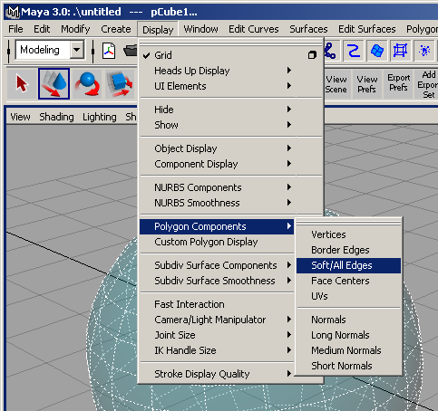
Figure 1-1How to show hard and soft edges in Maya.

Indexed Primitives
Make careful use of indexed or de-indexed primitives.
Rationale: The XBox runs better with indexed primitives. The PS2 runs better with de-indexed primitives.
If the art is processed for the PS2, but is not tristripped, use “p3ddeindex” to deindex the geometry.
XBox – indexed
PS2 – de-indexed.
GC – indexed

Triangle counts in Maya versus in-game
Tristripping and primgroups affect the number of triangles in a given mesh. In general many more triangles are created as part of tristripping but the overall size of the geometry in memory is reduced due to vertex re-use.
For example, the Bart high LOD model is 1700 triangles before processing. After processing the mesh using tristripping (and on the Xbox, p3dprimgroup) the following changes occur:
PS2: 2680 triangles; up 158%
XBOX: 2603 triangles; up 153%
GC: 2400 triangles; up 141%
The savings come in vertex re-use. There is between 70% and 50% savings in vertices when characters are tristripped.
Experiments with other character meshes have resulted in similar values. When calculating actual poly counts, one must make an adjustment of ~150% from the unprocessed art.
Note: Maya uses quads to define poly count, so to get an accurate pre-processed poly count triangulate the meshes first.
Recommend a triangle count of 1700 or less for the high LOD in Maya.

Alpha issues
- [PS2 Specific] Convert alpha textures to 4 or 8 bits.
Rationale: The Playstation 2 does not support the ARGB4444 texture format that is common on PC video cards. By default, textures with multiple alpha values will be stored as 32 bits in VRAM. Lots of alpha textures can quickly fill up VRAM. If a simple colour-key style alpha is desired, use a ARGB1555 format texture. 32 bit textures can be converted into 4 or 8 bit formats, preserving the alpha using the p3dimage tool. Tools that support palletized-with-alpha PNG images can also be used (Macromedia Fireworks for example).
- Beware of over-draw
Rationale: Several layers of alpha blended geometry are expensive to render. Rendering order of translucent and transparent objects is important (holes in the background map appear).
- Use Pure3D’s attribute to switch on transparency.
Rationale: Pure3D ignores Maya’s own transparency setting and uses its own.
How:
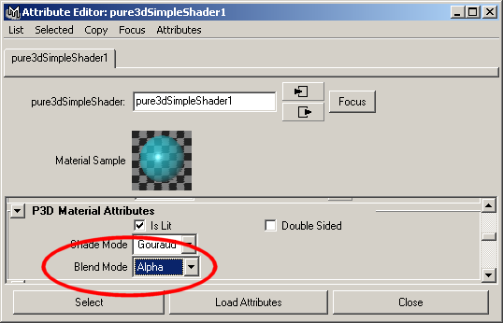
Figure 1-2 Switching alpha blending on with Pure3D shader attributes.

Draw distance
SRR 1 had a Draw distance that ranged from 600M to 20000M in the worst case. Simpsons II shall use a draw distance that stays fixed at 300M to prevent popping and frame rate slow-downs. This requirement forces the artists to design the worlds such that sight-lines and details keep the draw distance filled, but maintain a look of grand scale.

Texture issues such as 128x128 max size
- [PS2] Do not use specular lighting on world geometry or geometry that has large off screen portions close to the camera.
Rationale: The PS2 does not clip specularly lit polygons. This is a design feature of Pure3D to save speed. Specularly lit polygons will simply be dropped out once they touch the clipping planes.
- Use Pure3D’s attribute to switch on transparency.
Rationale: Pure3D ignores Maya’s own transparency setting and uses its own.
How:
Figure 1-3 Switching alpha blending on with Pure3D shader attributes.
- [Xbox Specific] Avoid the use of 1024x1024 textures- use smaller textures. 256x256, 8 bit textures should be the most commonly used.
Rationale: Textures of this size consume a relatively huge amount of memory. Their size will reduce the effectiveness of the texture cache unless they are used infrequently in a small area. The XBox has a total of “N” MB of memory for textures, but this is complimented with the DXTn compression that guarantees a 4:1 compression rate for 32 bit textures and 6:1 for 24 bit textures.
- [PS2 Specific] Use textures that are 256x256 or smaller.
Rationale: Textures of this size consume a relatively huge amount of memory. The PS2 only has a total of up to 2 MB or less of memory to use for textures (the PS2 has 4 MB of video RAM).

Physical limitations of PS2 hardware
Maximum 8 bit texture | 1024 x 1024
Maximum 16 bit texture | 512 x 512
Maximum 24 bit texture | 512 x 512
Maximum 32 bit texture | 512 x 512
- [PS2 Specific] Small texture chunks can be swapped in and out of memory effortlessly on the PS2 without hiccups. This can allow artists to break the 2 MB texture limit.
Rationale: The PS2 while limited in actual memory for textures, it does make up for it partially by allowing very fast texture swapping. The PS2 can upload ~5MB of textures per frame at a frame rate of 60Hz
- Use detail/multi-textures to break up large, tiled textures (i.e., walls and floors)
Rationale: The use of smaller, high frequency textures helps to hide the blurriness of large textures when the camera is relatively close. As the large texture pixelates on close-up the detail texture will come into view masking the blockiness of the underlying texture.
- Use texture skinning wherever possible (i.e., characters and world objects)
Rationale: Texture skinning reduces the number of expensive material state changes and increases cache efficiency. This technique will be used to produce a front and back skin for characters and to cover world objects. Skinning should not be used for objects that have tiled or repeated textures such as walls and floors. Using large textures in this way increases triangle strip length (there are fewer material boundaries to contend with), and reduces the amount of potential texture uploads per frame. See Tristripping.
Filtering and mipmapping of these textures will leak neighbouring pixels into the texture. Helpful hints to avoid neighbouring textures bleeding into each other due to filtering and mipmapping:
  - Stick with power of 2 subtextures
  - Leave a border in your UV coordinates
- Use the smallest format (N-bit) texture possible.
Rationale: 16 bit texture formats often work in place of 32 bit formats. Often an 8 bit texture will often look just as good as a 32 bit texture, but it takes a quarter the size. Four bit textures work well in many circumstances. 32 bit may only be required for background art.
XBox - The compressed texture formats can look even better, at a smaller size (the Xbox supports 4:1, and 6:1 compression modes).
- [PS2 Specific] Convert alpha textures to 4 or 8 bits.
Rationale: The Playstation 2 does not support the ARGB4444 texture format that is common on PC video cards. By default, textures with multiple alpha values will be stored as 32 bits in VRAM. Lots of alpha textures can quickly fill up VRAM. If a simple colour-key style alpha is desired, use a ARGB1555 format texture. 32 bit textures can be converted into 4 or 8 bit formats, preserving the alpha using the p3dimage tool. Tools that support palletized-with-alpha PNG images can also be used (Macromedia Fireworks for example).
- [Xbox Specific] Use texture compression (DXTn)
Rationale: Compressed textures require less system memory to store, and can increase the effective fill rate of the GPU. Be wary of compression artefacts though. The DXTn format is a lossy format, similar to JPEG.
Check art on console viewer or in-game to see if the textures are loosing too much detail and depth.
- Use mipmapping on large (wall and floor) textures.
Rationale: Texel look-up is faster for lower level maps as these maps are smaller. Note that Mipmapping increases texture memory requirements by 1.333.
- Reuse textures whenever possible.
Rationale: Due to the limited amount of texture space available on consoles, the reuse of textures where appropriate is encouraged.
- Every Material Node and Texture Node (some call it a "file node") must have a unique name.
Rationale: If the names are not unique then there will be a name collision within the texture database. Only one of the textures with the chosen name will be accessible.
- Do not use shading group names.
Rationale: Shading group names are not used by Pure3D.
- Duplicate texture filenames do not matter in P3D.
Rationale: As long as the MaterialNodes and TextureNodes are different(i.e if you have 2 different doors, both called "door.bmp", both will be loaded, as long as the MaterialNode & TextureNode names are different.
- Use the exact same MaterialNode and TextureNode names to re-use a texture on a different object.
Rationale: If you want to re-use the same texture on a different object, you must also use the exact same MaterialNode and TextureNode names, otherwise the texture file will be loaded twice into memory.
- Use a portion of an already existing texture to colour a face instead of using a colour only (no texture) material.
Rationale: This will eliminate the need for a completely new material when you already have the required colour in an already loaded texture.
Example: If you have an object with 3 different material colours (no texture), make up a small texture that has those 3 colours in it, and UV-map those coloured pixels onto your object, using only 1 material and 1 texture. This minimises the number of expensive material changes in a frame and allows the creation of longer tri-strips. Every time there is a material change, the tri-strip will be broken and a new one must be created

Shaders (Materials)
With bugs in the Maya Lambert shader when pre-lighting scenes and the huge number of options available on the “simple” shader, Simpsons II will create a set of custom shaders for the artists. These shaders are:
- Multilayerd shader
- Reflection shader
- Bilboarded additive-shader
- 2bit alpha shader
- Simplified unlit-shader
- 4bit alpha shader
- Environment Shader (fake reflections)
- Shadow map shader
- Animated texture shader

Primgroups—one of the most important but overlooked areas from SRR.
TBD

Skeletons
The general characteristics of the skeleton are outlined below.
- The core skeleton is symmetrical. Note that bones added for specialized secondary animation may break the overall symmetry of the skeleton.
- Secondary bones can be added on top of the core structure for each individual character.
- The proportions of the core skeleton can also be adjusted for individual characters.
- Retargeting of the skeleton to different models is supported.
- The intent is to use only a single skeleton for user characters and NPCs. Note that secondary characters that are not controlled by the player may use a simpler skeleton that is derived from this core skeleton.
- Less joints means less transformations that the run-time system will have to handle increasing performance. Consult w/the programmer as far as how many joints should be within the character to allow it the maximum range of motion yet manageable as far as data size and computation (overhead) goes.
- The position the model should have before creating the skeleton is the "default modeling pose". This is the commonly seen "arms out feet shoulder width apart" pose.
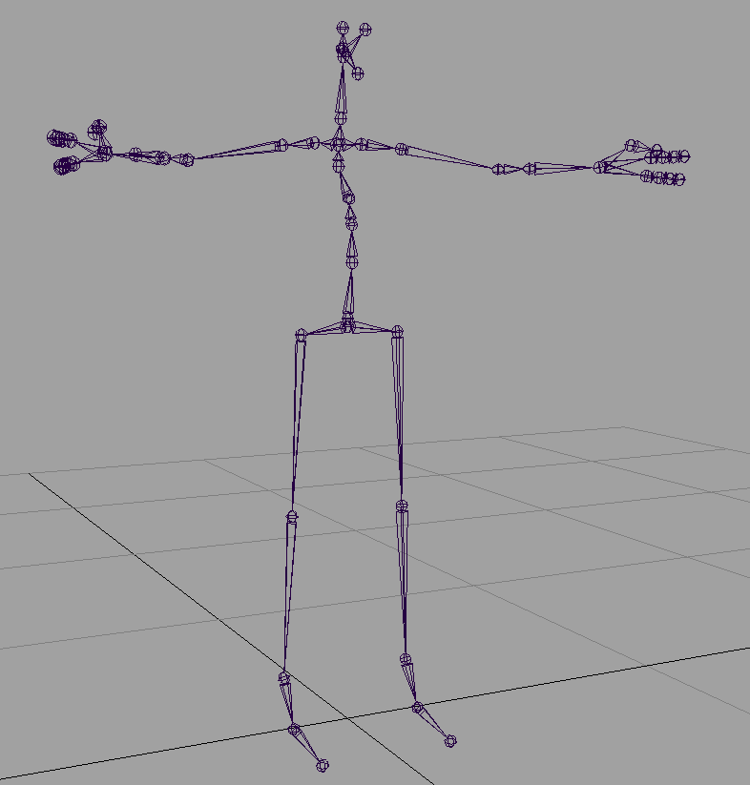
Figure 1-4 – Hierarchy of Core Skeleton in Maya

Joints
This section will enumerate the joints required by the game run-time.
Joint Hierarchy Ordering
The game run-time does not assume any hierarchical ordering of these joints. This is will be determined at the convenience of the modeler or animator who is constructing the skeleton.
Skeletal-type Independence
For any of the joints enumerated in this document, the joint name must be kept common. The upshot of this is that the run-time will be able to operate on any skeleton used in the game. Any joint that is not listed in this document can be named at the whim of the modeler/animator. However, we strongly recommend that a logical and consistent naming scheme be used for naming of the skeleton.

World Root
Naming:
World_Root
Description:
The world root is used to parent IK rigs and skeleton controls under and is used to position and scale the character in Maya for other Maya purposes

Motion Root
Naming:
Motion_Root
Description:
The Motion_Root is the skeleton root as far as Pure3D is concerned. The key points are:
- It contains X and Z translation only.
- It is used to describe the simple major motion of the character.
- It has the Character_Root as a dependent.
The motion root joint is placed underneath the character (at coordinate y = 0) and traces the characters movement path across the XZ plane. This joint will have T_{x,z} data and traces the path which the character moves in space.
The motion root coordinate data will be used in-game to translate the character in world-space.
So why do we have a motion root at all and not just use the character’s root joint? The main reason motion root is that it has full damping on a character’s lateral “sway” applied so that it traces a true arc or line for the character’s path. Having both roots will give the animated character translation in world-space along with a lateral sway.

Character Root
Naming:
Character_Root
Description:
The Character_Root is the first real bone in the hierarchy and contains all 3 degrees of freedom (DOF) in rotation and translation. An animator uses this joint to describe the subtle motion of a characters center of mass (i.e., side-to-side hip motion) and all Y translation.
The Character_Root joint is placed at the character’s pelvis. This joint will have Rot_{x,y,z} and T_{x,y,z} data.
It encodes the location and rotation angle of the character at the pelvis. The game will use the location of this joint to derive the in-game location of effectors such as the hands and feet.
In case you went straight to this section, we should contrast the character root with the motion root. The main difference is that the character root may have a lateral “sway” relating to counterbalancing of a body at the area as the body moves forward. So if we were to project the character root onto the XZ plane (by setting y = 0) for the duration of the animation, and overlaying this path onto the path mapped out for the motion root, we would find that the line made by the character root would criss-cross the line made by the motion root.

Orientation Root
Naming:
Orientation_Root (sometimes called Facing_Root)
Description:
The Orientation_Root is used to describe the facing direction of the character - it is animated by the artist but:
- Unlike the Motion_Root it has no dependencies;
- It contains only Y Rotation.
The orientation root joint encodes the facing direction of the character using Rot_{y} data. The orientation direction is essentially the direction that the character has its face oriented towards. So recall that while the character root also records the pelvic forward-facing direction, the orientation root represents the head facing direction. For instance, a boxer’s stance is an example where the pelvic forward-facing direction differs from that of his facing direction.

Hypergraph Composition in Maya
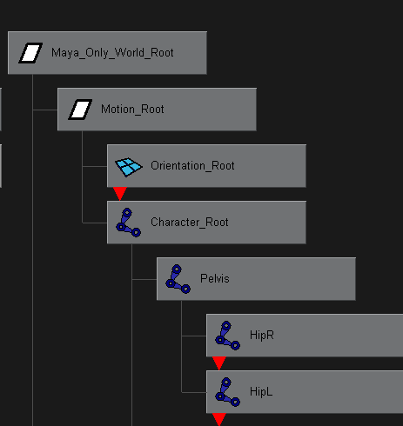
Figure 1-5 – Hypergraph in Maya
The pivots in Maya are a curtail area to get your head around.
Maya contains three transforms which are used to describe the local orientation for each joint, whereas, Pure3d only sees two of these. This fact becomes very apparent when dealing with issues like mirroring.

Lights
- Use as much pre-lighting (CBV lighting) as possible. All static/world geometries should be pre-lit.
Rationale: Pre-lighting bakes colour values into the geometries vertices. It is faster for the graphics hardware to “light” the polygons using the colour values in the vertex than it is to use real lights. This frees up real lights for use with characters.
How to apply and view pre-lighting:
- Select all materials on a mesh and set the P3D material attribute “Lit” flag to “NO”. See Figure 1-6.
- Select the geometry. Select “Edit Polygons->Colors->Prelight” and apply. See
- Select “Display->Custom Polygon Display”. Set “Color Material Channel” to “Ambient + Diffuse”. See Figure 1-8
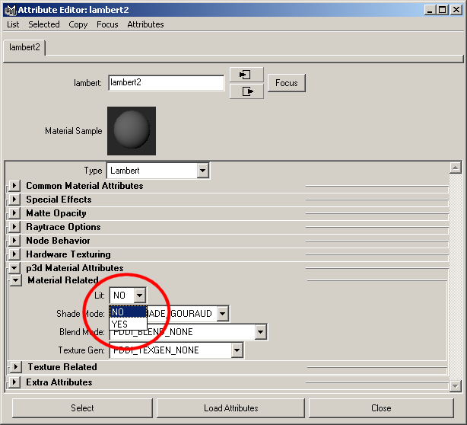
Figure 1-6 Set Lit to NO to flag a material as being pre-lit.
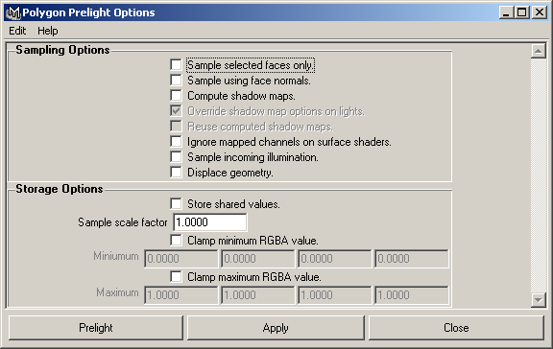
Figure 1-7 Applying pre-lighting to a selected geometry.
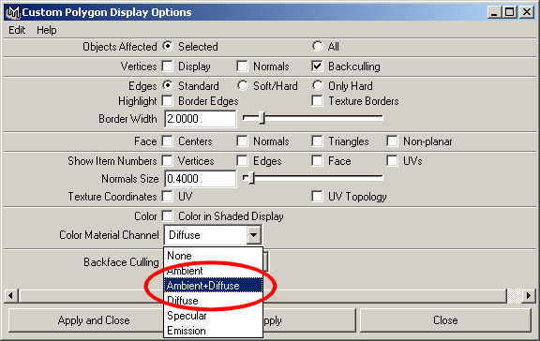
Figure 1-8 Setting custom polygon display options to show CBV lighting.

- Use either lit or unlit for all materials on the same mesh, never both.
Rationale: The Pure3D runtime will only support one or the other. A warning will popup if you try to export both lit and unlit materials on a single mesh.
- No lighting shall be applied to any exported world geometry. Lights shall only be placed in the scene for the lightmapping tool to calculate the lightmaps and for previewing purposes. There is no limit of the number of static lights in the scene. Dynamic objects will handled separately.
Rationale: A lightmapping tool shall be used to light the scene based on the position of lights placed in the scene.

Lighting Restrictions
A few anomalies have been observed between Pure3D and Maya. Although the game tries to compensate for these as best as possible, it is helpful to keep these in mind.
Maya attenuation and Pure3D/OpenGL/Xbox attenuation do not match. The attenuation in Maya falls off about 1000-1500 times faster then in Pure3D. This means when creating a light in Maya the intensity values will be much higher then they should be in the game. Lights to be used in runtime vs. pre-lighting must have much less intensity.
Intensity for spotlights always export as one in Pure3D. This is a bug to be fixed (tracker #449).
Maya adds the fall-off for the penumbra of a spot light cone to the outside of the cone. It also adds the penumbra angle on both sides of the cone. Thus, a spotlight in maya with a 90 degree cone and a 10 degree penumbra will have a total cone angle of 110 degrees. In Pure3D, the cone is a total of 90 degrees with the inside cone being 80 degrees (5 degrees on each side of the cone).
When animating the intensity of lights in Maya, it caps the intensity at 1. Thus if you have an animation of the intensity form 1 to 2 over 60 frames you will get 60 frames of full white.

Character animations are always animated on a flat surface. The game run-time will translate the characters vertically as needed when terrain elevation changes take place.
So why should there be lateral sway? Simply, bipedal characters tend to shift at the pelvis to counterbalance the forces on the body as it pushes off with one of the legs. Consider that such compensation is required since each leg is essentially off-axis from where the force should be applied to move a body forward

